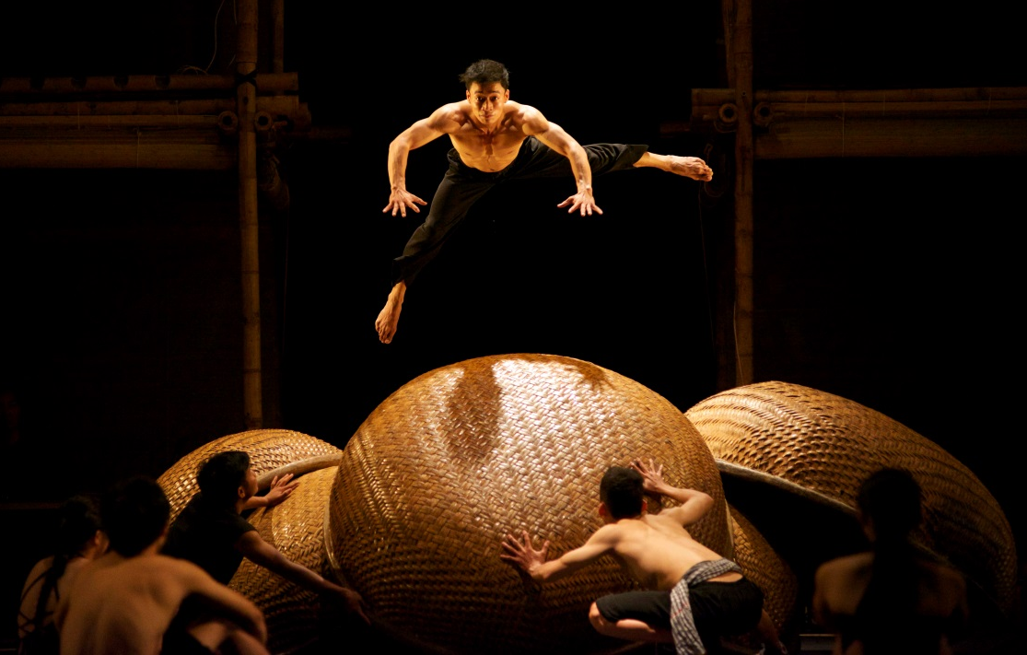
Global Conversations – Asian Pacific
À Ố Làng Phố
Sydney Opera House in partnership with the Asia Education Foundation presents
Global Conversations

Registration Form

Schools need to participate in both Stage One on the 13 June and Stage Two on the 18 June at the designated time zones for their country.

Please complete the information in the table below in order to register your place in the Global Conversations workshop.

By registering to participate in Global Conversations you are agreeing that you will not record and will not permit any students to record any part of the streams (either the performance of À Ố Làng Phố or the Global Conversations discussion) in any way.

Once registration is completed you will be required to sign an agreement confirming your participation in the Global Conversation Asia Pacific Program. Bookings need to be submitted by 7 June 2019.

Please email the booking information Julia Doszpot Digital Programming Coordinator on jdoszpot@sydneyoperahouse.com

Teacher Full Name
School Name
School Address
Teacher Email Address
Teacher Contact Number
Class Year Level
Number of students in class
Level of English spoken (International schools)
Stage One: 13 June | YES I can participate
Stage Two: 18 June | YES I can participate
Do you consent to Sydney Opera House and its presenting partners sending you information about other similar workshops and educational opportunities (Type yes/no)

